# INF10025 Data Management and Analytics

# Task 5 – Pass Submission

Student Number: 104071453  
Student Name: Marco Giacoppo

### Pass 5a

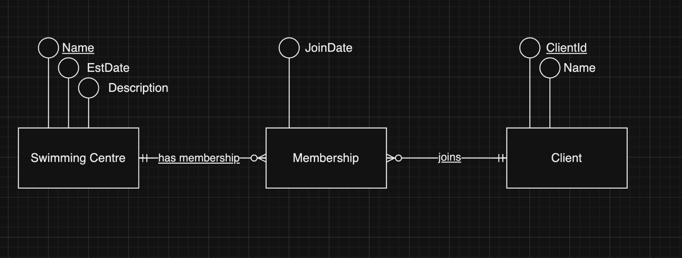

### Pass 5b

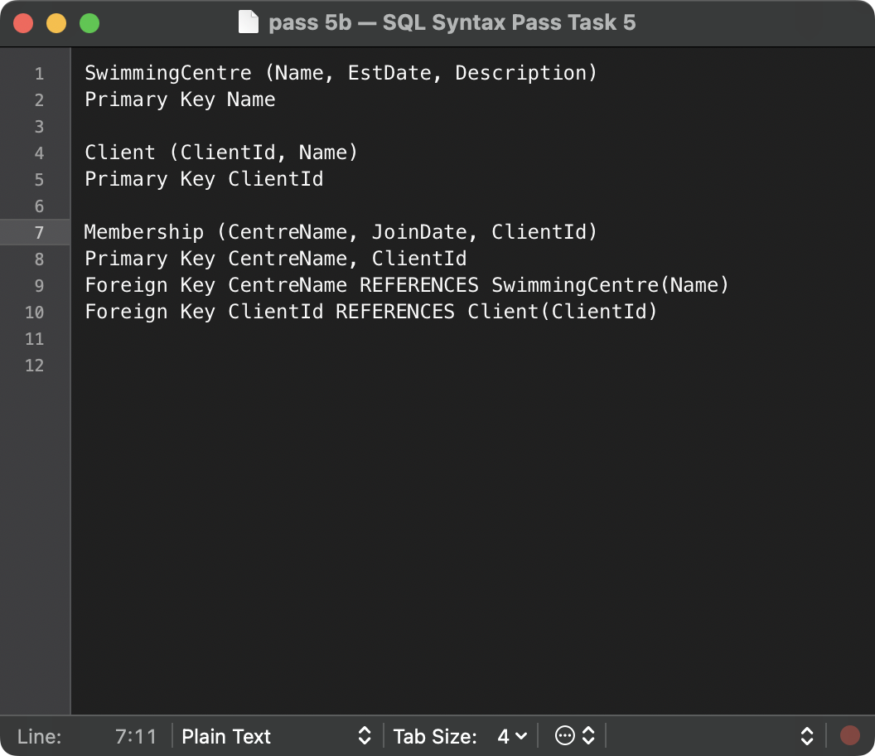

### Pass 5c

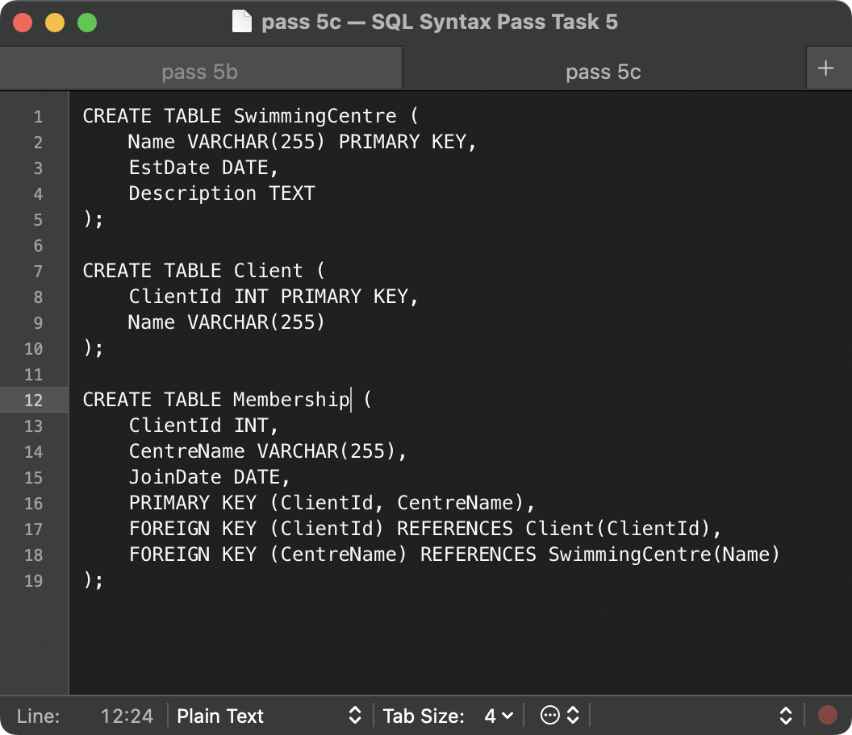

### Pass 5d

Normalization is a process used in database design to organize tables and reduce redundancy and dependency within the data. The goal is to ensure data integrity by eliminating or minimizing data anomalies such as insertion, update, and deletion anomalies.

### Pass 5e

|  |  |  |  |  |  |  |
| --- | --- | --- | --- | --- | --- | --- |
| **CustId** | **Name** | **Phone** | **CarRego** | **MakeModel** | **StartDate** | **ReturnDate** |
| 125 | John Coles | 0401112233 | 1AU8HK | Mazda 3 | 31/08/2020 | 7/09/2020 |
| 125 | John Coles | 0401112233 | 1LM3AB | Hyundai i30 | 14/11//2020 | 21/11/2020 |
| 278 | Erin Trump | 0466121455 | 1AU8HK | Mazda 3 | 12/09/2020 | 19/09/2020 |
| 278 | Erin Trump | 0466121455 | 1KA2CA | Toyota Camry | 1/10/2020 | 8/10/2020 |
| 278 | Erin Trump | 0466121455 | 1CZ8JK | Mazda 3 | 10/11/2020 | 12/11/2020 |
| 278 | Erin Trump | 0466121455 | 1AU8HK | Mazda 3 | 26/11/2020 | 1/12/2020 |
| 721 | Emma Knox | 0423544117 | 1LM3AB | Hyundai i30 | 10/09/2020 | 13/09/2020 |